Research Report - DRAFT

**Black huckleberry: Implications of logging, site and climatic factors on plant cover and berry abundance in British Columbia**

Julia Chandler, Evelyn Hamilton, Garth Mowat, and Cora Skaien

April 25, 2025

# 1. INTRODUCTION

Black huckleberry (*Vaccinium membranaceum)* berries are a very important food source for grizzly bears (McLellan 2018, 2023, Lamb et al. 2018; Proctor et al. 2023) which are a wildlife species of special concern in Canada (COSEWIC 2012, Figure 1). The berries have also long been an important food for indigenous and more recent North American people (Spencer et al. 2020). Despite the interest in understanding and increasing habitat suitability for huckleberry and grizzly bears (e.g., Lamb et al. 2018; Proctor et al. 2023), little work has been done to determine how timber harvesting and silvicultural practices influence berry production. Burton et al. (2000) and Beaudry et al. (2001) provided management recommendations for areas in northern BC; and Lamb et al. 2018, Proctor et al. 2023, and McLellan (2023) provided information relevant to management in the southeast.

This study was done to determine how climatic conditions, site factors and forestry practices influence plant cover and huckleberry production and to provide guidelines regarding how to maintain and enhance huckleberry production in grizzly bear habitat.

Huckleberry is common throughout British Columbia in dry to moist forests and openings in montane and subalpine zones. It is most common in the Engelmann Spruce – Subalpine Fir (ESSF), Interior Cedar – Hemlock (ICH), and Sub-Boreal Spruce (SBS) Biogeoclimatic Ecosystems Classification (BEC) zones, although it occurs across most of the province (Figure 2). Its distribution in BC is described in [BEC Regional Field Guides](https://www.for.gov.bc.ca/hre/becweb/resources/classificationreports/index.html) (BECweb 2025).

Figure 1. Black huckleberry (*Vaccinium membranaceum*) berries and leaves in early fall.

# 2. METHODS

Sampling occurred in locations with bear foods and did not include sites where bear foods (i.e. berries) were not expected to be found (See Lamb 2019, Clarke 2022, Proctor et al. 2023 for site selection and sampling methods). This study does not represent a comprehensive provincial assessment as sampling intensity varied by BEC subzone variants and many variants were not sampled.

Plant cover (%), berry abundance (#/100m2) and associated predictor variables were collected from 864 sites across the province in 2016, 2017, 2018 and 2022 (see Figure 2A for North American huckleberry occurrence, Figure 2B for plot locations and 2C for provincial maps of occurrence, cover, fruit presence and fruit abundance). The predictor variables included site variables[1] (canopy cover, elevation, latitude, longitude, slope and aspect), site history (unlogged or various silviculture systems including clearcut and clearcut with reserves), and were modelled with climate data for the current year and the two preceding years, referred to as the “previous year” or “two years prior”. Climate data were downloaded from the ClimateBC database (see [ClimateBC.ca](https://climatebc.ca/)). Data were analysed for the ESSF, ICH and SBS zones.

Figure 2. Distribution of black huckleberry (*Vaccinium membranaceum*) across North America[2] (A); Distribution of black huckleberry (*Vaccinium membranaceum*) sample sites (*n*=864) located in SBS, ICH and ESSF biogeoclimatic zones across British Columbia, Canada; and provincial maps of black huckleberry occurrence, plant cover, fruit presence and fruit abundance (Lamb 2019) (C).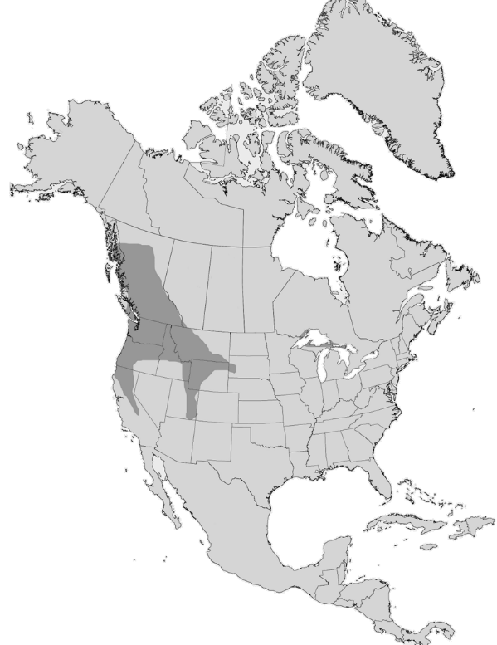 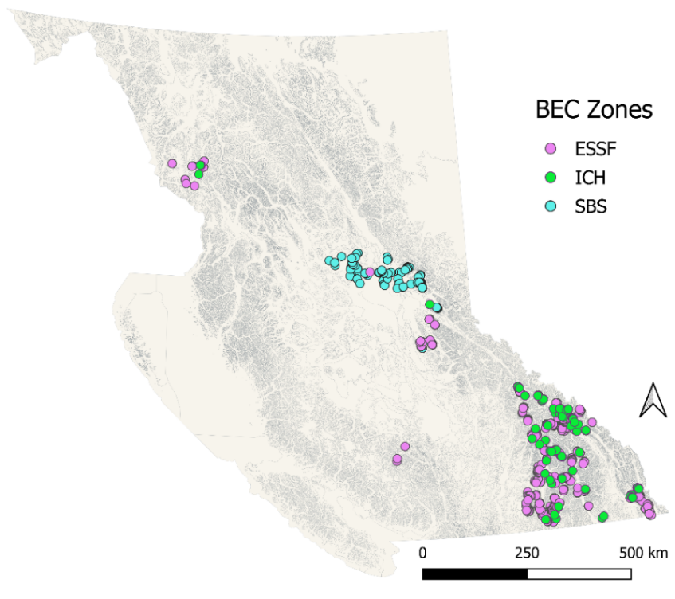

2 A.

2 B.

2 C.

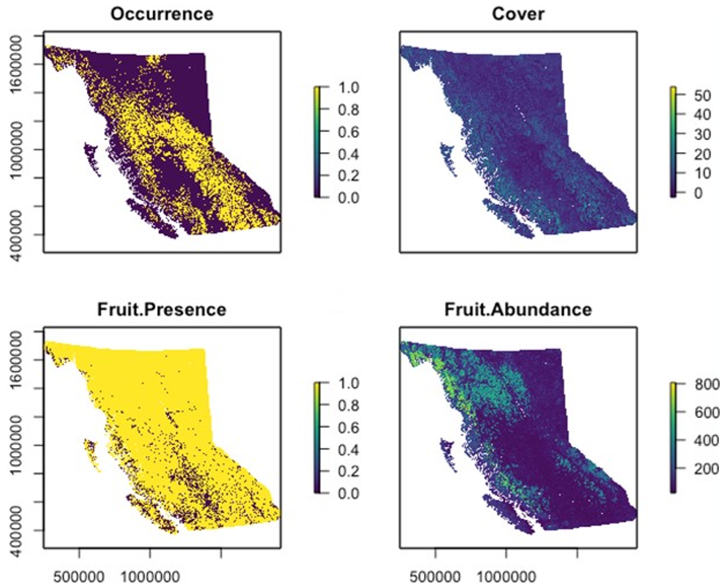

### 2.1. Field sampling

Buffaloberry plant cover (%) and berry abundance (#/100m2) (Table 1) and associated site data[3] (Table 2) and site history (i.e. logged or not; Table 3) were collected in the field using standard ecological methods (British Columbia Ministry of Forests and Range and British Columbia Ministry of Environment 2010). Site aspect (i.e. azimuth) values were converted to ‘folded aspect’[4].

Buffaloberry plant cover and berry abundance data were collected within 0.82 m diameter hoops (0.53 m2) set within larger 100m2 plots. All plants within the 100m2 plot had a 0.82 m diameter hoop placed around it to determine plant cover and berry abundance. Each hoop represented ~0.5% of the 100 m2 plot, allowing for extrapolation of berry abundance to the 100 m2 plot level, based on species cover within the 100 m2 plot. If the plant did not fill the entire hoop, then the number of berries counted was divided by the proportion of the hoop for which the plant covered (e.g., if 200 berries were counted and the plant covered 60% of the hoop area, then there would be 200/0.60 = 333 berries/0.53 m2). Sometimes with buffaloberry, when the plant was particularly productive, the top three representative branches were counted and then extrapolated to the total number of branches present within the hoop.

### 2.2. Statistical analysis

We constructed models using a recursive partitioning method with the R rpart package (Therneau and Atkinson 2023) with default settings (*p* < 0.01) in three key zones - the ESSF, ICH, and SBS. One model was generated for each response variable (huckleberry plant cover and berry abundance) incorporating all predictor variables (*n=*744) for each of the three key zones (Tables 1 and 2). See the Addendum for details on the variables included in the models.

Decision trees representing each model were generated using the rpart.plot package (Milborrow, 2024). The rpart analysis identifies the predictor variables that best explain the response (i.e. buffaloberry cover or berry abundance). The decision tree first splits the tree into two “branches”. The variable associated with the first split in the tree is the predictor variable that is best correlated with the variation in the response variable. Each binary split maximizes the between-branch sums of squares (or equivalently minimizes the pooled within-branch sums of squares) of the dependent variable. The optimal split is determined for all predictor variables and the one that yields the best separation becomes the first split. The process then repeats for each subsequent tree branch, calculating further subsets of the data until no appreciable improvement in sums of squares can be made.

# 3. RESULTS

## 3.1. ESSF Zone

The best sites for huckleberry cover and berry abundance in the ESSF were open canopy (<35% canopy cover), logged, sloping sites found between 1700-1800m asl. Model results indicated four primary variant groups within the ESSF zone. In logged sites where the maximum temperature in January in the current year (Tmax01) was >=-4.2oC (i.e. a warmer January) cover was greater in the Group 1[5] BEC units compared to Group 2[6] BEC units. Berry abundance was positively correlated with huckleberry plant cover (Table 4), varied considerably by BEC units and was greater in Group 3[7] vs Group 4[8] BEC units. In Group 4 BEC units berry abundance was greater in logged sites. In Group 3 BEC units berry abundance was impacted by climatic conditions in previous years.

## 3.2. ICH Zone

Cover and abundance were greatest in inclined sites, open areas with less canopy cover, logged sites, higher elevations, more southerly locations and in sites that generally experience cooler moister weather condition. Cover was greater in logged sites in areas that generally experience moister cooler May conditions and where June the previous year had been warmer. In logged sites, % canopy cover had little impact on berry abundance. Berry abundance was greater where there had been more May precipitation the previous year. In the sites that had less precipitation the previous May, berry abundance was greater where overall that spring had been moister and cooler.

## 3.3. SBS Zone

The sites sampled in the SBS were almost all forested and featured low plant cover and berry abundance, limiting conclusions. Huckleberry cover and berry abundance were generally greater where conditions were cooler and moister, i.e. at higher elevations and also greater in more southern locations. Cover was somewhat greater in sites that had received more snow in the previous September. Berry production was greater where huckleberry cover was greater and on cooler aspects and where there had been higher maximum temperatures in December of the current year.

# 4. CONCLUSIONS AND DISCUSSION

## 4.1. Summary

Overall, the best sites for huckleberry cover and berry production were in the ESSF zone; next best sites were in the ICH with poorest sites being in the SBS zone. Best berry production was generally found in the sites with higher huckleberry cover and lower canopy cover. Logged sites typically had lower canopy cover. In the ESSF, best sites were between 1700-1800m asl. In the ICH and SBS best sites were at higher elevations, in more southerly locations. Weather conditions in previous years influenced huckleberry cover and berry abundance. These results suggest huckleberry is well adapted to cooler, moister climatic conditions typical of the ESSF, and higher elevation ICH and SBS zone sites. Severe cold winters temperature were detrimental to berry production in all BEC units.

These results, however, are constrained to the years sampled (only done in one year for each site) and the sites sampled (a subset of the possible sites in each subzone and a subset of the subzones in each zone). Another caveat is the limitation of information regarding details on history and nature of “logged” vs “unlogged” sites which may include a range of conditions.

### 4.1.1. Relationship between huckleberry plant cover and berry abundance

We found a positive relationship between huckleberry cover and berry abundance. Because berry abundance varies so much year to year, using huckleberry cover as a metric to identify best sites to manage for abundance is reasonable.

4.1.2. BEC unit

In the ESSF cover and berry abundance varied by BEC subzone and variants. Huckleberry cover was highest in the ESSF (mean=19.1%, sd=11.2), followed by the ICH (mean=13.5%, sd=11.44) and significantly lower in the SBS (mean=1.8%, sd=1.06) (Figure 3). Berry abundance was also highest in the ESSF (mean=2016/100m2, sd=1797), followed by the ICH (mean=1724/100m2, sd=2009) (Figure 3). There were also differences between logged vs unlogged sites among BEC variants and zones (Figures 4 and 5).

Huckleberry is well adapted to the cooler, moister climatic conditions typically found in the ESSF and higher elevation ICH zones (see Klinkenberg 2020, BECweb).

### 4.1.3. Canopy cover

Optimal tree canopy cover will vary depending on the climatic and site factors and some canopy cover is likely beneficial in exposed drought and frost prone sites, whereas on moister and/or cooler sites tree cover will likely negatively impact huckleberry berry abundance (Appendix 1).

In wetter climatic regions such as the ESSF and ICH, we found huckleberry plant cover and berry abundance were generally greater in sites with lower canopy cover (<50%); in areas with warmer drier climatic conditions such as that found in the SBS zone, this limitation was not observed, and some canopy cover was beneficial for huckleberry cover.

Canopy cover can provide shade, moist conditions and protection from frost (Minore, Smart and Dubrasich (1979), Forney (2016), Barney (1999), however competition for resources from trees and other plants can reduce abundance of berry patches (Barney 2005). Canopy cover greater than 30-50% has been found to decrease overall black huckleberry plant growth (Stark and Baker, 1992; Martin, 1996; Barney 1999, Burton, 2001, Forney 2016) and berry production (Forney 2016). Optimal canopy cover for berry production was 34% in west-central Alberta (Nielsen et al. (2004b), <30% in NW Montana (Martin 1979, 1980), 20% in SE BC (Keefer et al. 2011) and about 10% in the central BC ICHmc subzone (Burton 1998).

Canopy cover growth and vaccinium plant recovery after logging are interrelated by space; and these interrelationships are difficult to quantify over time in this study. Huckleberry cover increases as the shrub recovers from logging, but this is in the context of the negative effect of shading due to the increase in canopy cover 20 years post-harvest (at the ESSF and ICH sites sampled in this study). Only 9% (8/91)SBS sites were logged whereas 61% (385/631) of the ESSF sites were logged and 54% (55/102) of the ICH sites were logged, therefore this study does not adequately compare results from logging within the SBS with that from other zones.

### 4.1.4. Climatic/weather conditions

Plant cover and berry abundance were correlated with climatic conditions and particularly those associated with temperature and moisture regime. Climatic conditions in previous months, seasons and years were often related to berry yield. In the SBS and ICH, cooler, moister conditions in preceding time periods were related to higher berry yields. Alternatively, exceedingly low temperatures may mean exposure of plants to freezing damage if snowpack levels were sufficiently low

Our results are consistent with those of other studies from BC and nearby areas in confirming the importance of climatic conditions in terms of huckleberry cover and berry abundance (Appendix 2). Weather conditions in current and preceding years impact berry production (Holden et al. 2012, Friesen et al 2016, McLellan 2023); this was likely due to the effect on the general health of the plants and bud set, which occurs the year before berry production and would influence subsequent berry abundance. Hence there could be significant differences in berry abundance, with the same level of plant cover, in different years.

Deep snow cover helps protect plants from exposure to freezing temperatures and desiccation that can have detrimental effects on flower buds and hence berry abundance (Minore et al 1979, Stark and Baker 1992). A near freezing dormant period has been shown to be beneficial for berry production (Barney 1999). However, heavy spring rains, hail and frost can negatively impact flowering and pollination success, and prolonged summer snowpack and cold temperatures as well as drought and hot temperatures can lead to failure of berry crops (Martin 1983, Stark and Baker 1992, Hobby and Keefer 2010, Holden et al. 2012, McLellan 2023). Holden et al. (2012) found that berry production was positively correlated with July diurnal temperature range, first snow free date, maximum snow water equivalent and November-April cumulative precipitation, and negatively correlated with the number of growing degree days above 10C and 50C and April-June average minimum temperature.

It is a complex set of climatic factors at multiple temporal scales influencing berry abundance and it is important that managers implement management practices designed to enhance or maintain berry patches over a wide range of site conditions such that if weather conditions are unfavourable in one area and/or in one year, there will be other areas in which weather conditions are better in terms of berry production. Climatic determinants from past years may not be a reliable indicator of berry abundance in the future given the differences between past, current and predicted climatic conditions (Prevey et al. 2020).

### 4.1.5. Site factors

We found huckleberry plant cover and abundance are associated with certain site factors and this differed by zone (Appendix 3). Both cover and abundance were generally greatest between 1700 and 1800m asl in the ESSF. In the ESSF and ICH, inclined warmer aspects were somewhat more favourable for huckleberry; in the ICH and SBS, higher elevation sites provided better conditions.

Our results are consistent with others who determined that favourable conditions for plants and berries are more likely to be found in at higher elevations and in cool moist climates - i.e. on Mt. St. Helens (Hunn and Norton 1984, Yang 2008), in mid-elevation and subalpine sites on Mt Hood Oregon (Norton et al. 1999), and in BC (Proctor et al. 2023). Proctor et al. (2023) found good huckleberry berry patches were more common on mid vs upper slope sites, with low slope anglesand more likely to occur on W-facing slopes.

## 4.2. Implications of forest management practices

We found generally greater huckleberry cover in logged areas and somewhat greater berry production; there was a greater positive implication of logging for cover than for berry abundance (Appendix 4). Canopy cover was generally lower in logged sites, which makes separating the individual influences of logging vs canopy cover on abundance challenging, but logging appears to be a means to reduce canopy cover to create favourable conditions for huckleberry abundance. .

Previous research has demonstrated a complex, non-linear relationship with huckleberry response with time since logging. Good berry production has been observed in clearcuts across many studies (Nielson et al. 20024a, Proctor et al. 2023, Souliere et al. 2020), particularly in winter logged sites that were not planted or treated with herbicide (Proctor et al. 2023) and in sites that were not scarified (Martin 1983). Further, good berry production was found in stands that were logged 10 years or more prior, but less than 20 years (Souliere et al. 2020, Proctor et al. 2023). Similarly, mature forests had poorer berry production compared to younger stands on cooler aspects in NW Montana; however, in this same study, berry production was lower on logged sites on dry warm aspects (Martin 1983). Thinning overstory trees increased light availability to understory vegetation, extending the successional period conducive to growth and abundance on cool aspects (Simonin 2000). Forest management activities that negatively impact the presence and abundance of plants (e.g. mechanical site preparation, summer logging) will likely have negative impacts on berry production (Martin 1983; Proctor et al 2023).

Our results and those of others (Martin 1983, Simonin 2000, Souliere et al. 2020, Proctor et al. 2023, Nielson et al. 2024a, W. Mackenzie pers comm 2024) suggest that berry production will decline over time as forests develop and the canopy closes. Silviculture practices that speed up the development of a dense canopy such as high stocking levels, brushing, and fertilization will therefore likely be detrimental to berry production.

Management activities should focus on the most suitable areas with a goal of maintaining and enhancing huckleberry cover by providing the appropriate conditions. Activities should aim to provide an open canopy and adequate snow protection/cover over space and time to limit frost damage and provide for sufficient soil moisture, considering stand development projections and current and potential future climatic conditions.

## 4.3. Predictions in consideration of climate change

The distribution of huckleberry shrubs is predicted to change in the future, with one study predicting a decrease in suitable habitat of 5-40% at lower latitudes and an increase of 5-60% at higher latitudes in coastal western North America, from southern California north through British Columbia and east to central Alberta and Montana by 2100 (Prevey et al. 2020). Another study predicted an overall increase in suitable habitat by 84-122% in the southern Canadian Rocky Mountains by 2080, with more suitable habitat at higher elevations (Roberts et al. 2014).

The phenology of berry production in huckleberries is predicted to advance by as much as 24-52 days by 2100, and result in earlier flowering that will be more susceptible to spring frosts, and this may lead to subsequent reduction in berry yield (McLelland et al. 2020; Prevey et al. 2020).

# 5. MANAGEMENT RECOMMENDATIONS

## 5.1. Identify areas where management is most likely to lead to good berry production

1. Use the results of this study in conjunction with other sources of information to identify geographic areas known to support high huckleberry cover. Our results suggest that in general, within the range of sites sampled, the ESSF provided the best conditions for huckleberry, followed by the ICH and the SBS. We found in the ESSF, the best sites were inclined sites around 1700-1900m asl; in the ICH and SBS the best sites were at higher elevations within those zones and in more southerly locations.
2. Use the vegetation tables in the BEC field guidebooks to determine the site series that feature significant amounts of huckleberry in mature forests as these are likely to provide for the greatest huckleberry cover in subsequent seral stages after logging.
   1. Use the BEC system field guides, subzone maps and projections of future climate envelopes to identify the areas where management to enhance huckleberry plant cover and berry production is most likely to be successful now and in the future (see [BECweb](https://www.for.gov.bc.ca/hre/becweb/resources/classificationreports/index.html), [Centre for Forest Conservation Genetics | CFCG | UBC Forestry](https://cfcg.forestry.ubc.ca/)).
   2. Use PEM/TEM maps of site series where available to map key candidate sites. Otherwise, map areas of higher huckleberry cover using the remote sensing-based huckleberry mapping where available (such as done by [Clarke, 2022](https://open.library.ubc.ca/media/stream/pdf/24/1.0413210/3)).
   3. In site series where huckleberry is or will likely be abundant, plan to maintain and/or enhance huckleberry plants.

## 5.2 Plan operations

1. At the regional scale, locate and schedule forest harvesting to provide for a range of suitable conditions such that when there are unfavourable weather conditions in one area, other places with suitable conditions will be more likely to exist.
2. At the landscape level – locate and schedule forest harvesting to provide for open canopy sites within watersheds and across Grizzly Bear Population Units over time.

## 5.3 Implement stand level practices that will maintain or enhance huckleberry cover

* 1. Implement silvicultural practices (e.g. alternative silviculture systems) that provide open canopy berry patches over time.
  2. Implement management practices that minimize damage to huckleberry plants during logging (e.g. avoid widespread use of heavy machinery when sites have limited snow cover).
  3. Avoid mechanical site preparation that damages or destroy huckleberry plants.
  4. Consider the use of prescribed burning to enhance huckleberry cover by reducing the abundance of competing shrubs like rhododendron and azalea.
  5. Maintain open berry patches within cutblocks by reducing conifer stocking or use cluster planting with openings.
  6. Avoid widespread intensive forest management practices designed to speed up canopy closure across a site (e.g. mechanical brushing, herbiciding, fertilization) or use topical treatments rather than broadcast application.
  7. Consider periodic entry into blocks to remove some overstory trees to help retain open berry patches in the long-term.

# 6. REFERENCES

**Barney, D.** 1999. Growing Western Huckleberries. Moscow, ID: Agricultural Publication of Cooperative Extension System, University of Idaho. 22 p.

**Barney, D.** 2005. Prospects for Domesticating Western Huckleberries. Small Fruits Review. 2 (1):15-29. See Forney 2016.

**Beaudry, L., M. Martin and J. Paczkowski.** 2021. Using Silviculture to Maintain and Enhance Grizzly Bear Habitat in Six Variants of the Prince George Forest Region. Prepared for Habitat Branch Ministry of Environment, Lands and Parks. Victoria, British Columbia.

**BECweb.** 2025. Biogeoclimatic Ecosystem Classification Program Website. <https://www.for.gov.bc.ca/hre/becweb/resources/classificationreports/index.html>. [Accessed April 22, 2025].

**British Columbia Ministry of Forests and Range and British Columbia Ministry of Environment. 2010**. Field Manual for Describing Terrestrial Ecosystems (2nd ed., 266 p). Land Manag. Handbook (25), Victoria, BC: Research Branch B.C. Ministry of Forests and Range. <https://www2.gov.bc.ca/assets/gov/environment/plants-animals-and-ecosystems/conservation-data-centre/field_manual_describing_terrestrial_ecosystems_2nd.pdf>. [Accessed April 24, 2025].

**Burton, P.** 1998. Inferring the Response of Berry-Producing Shrubs to Different Light Environments in the ICHmc. FINAL REPORT. SCBC Project Number FR-96/97-118. FRBC Project Number SB96030-RE Unpublished.

**Burton, P., Burton, C., and McCulloch, L.** 2000. Exploring Options for the Management of Wild Berries in the Kispiox Forest District: Phase One of a Pilot Project Focusing on the Suskwa River Area. Prepared for the B.C. Ministry of Forests, Kispiox Forest District, Hazelton, B.C.

**Burton, P.J.** 2001. Response of berry-producing shrubs to different light environments in northwestern British Columbia. Unpublished Report, prepared by Symbios Research and Restoration. Smithers BC.

**Clarke, M. 2022**. Quantifying grizzly bear (*Ursus arctos*) habitat selection for a seasonal resource, the Canadian buffaloberry (*Shepherdia canadensis*) in southern British Columbia. MSc. UBC Okanagan, Kelowna, BC. <https://open.library.ubc.ca/media/stream/pdf/24/1.0413210/3>. [Accessed April 25, 2025].

**COSEWIC. 2012**. COSEWIC assessment and status report on the Grizzly Bear Ursus arctos in Canada. Committee on the Status of Endangered Wildlife in Canada. Ottawa. xiv + 84 pp. <https://publications.gc.ca/collections/collection_2013/ec/CW69-14-166-2012-eng.pdf>. [Accessed April 25, 2025].

**Friesen, C.** 2016. Ecology and Management of Big Huckleberry Literature Review. USFS R6 Ecology Program. <https://docsbay.net/doc/960516/ecology-and-management-of-big-huckleberry>. [Accessed April 25, 2025].

**Forney, A.** 2016. Patterns of harvest: Investigating the social-ecological relationship between huckleberry pickers and black huckleberry (*Vaccinium membranaceum* Dougl. Ex Torr.; Ericaceae) in southeastern British Columbia. M.A thesis, University of Victoria, Victoria, BC.

**Hobby, T. and M.E. Keefer.** 2010. A black huckleberry case study in the Kootenay region of British Columbia. BC Journal of Ecosystems and Management 11(1&2):52–61. <https://jem-online.org/index.php/jem/article/view/66/24>. [Accessed April 25, 2025].

**Holden, Z.A., Kasworm, W.F., Servheen, C., Hahn, B., Dobrowski, S.** 2012. Sensitivity of berry abundance to climatic variation in the Cabinet-Yaak Grizzly Bear Recovery Zone, Northwest United States, 1989-2010. Wildlife Society Bulletin, DOI: 10.1002/wsb.128.

**Hunn, E.S. and Norton, H.J.** 1984. Impact of Mt. St. Helens ashfall on fruit yields of mountain huckleberry, *Vaccinium membranaceum*, important Native American food. Economic Botany. 38(1): 121-127. Contact [cfriesen@fs.fed.us](mailto:cfriesen@fs.fed.us) or <http://ecoshare.info/> for a copy.

**Keefer, M., Cocksedge, W., Munro, R., Meuleman, J., and MacPherson, N**. 2010. What about the berries? Managing for understory species. Royal Roads University The Centre for Livelihoods and Ecology.

**Klinkenberg, B.** (Editor) 2020. E-Flora BC: Electronic Atlas of the Flora of British Columbia [eflora.bc.ca]. Lab for Advanced Spatial Analysis, Department of Geography, University of British Columbia, Vancouver.

**Lamb, C.T., Garth, M., Reid, A., Smit, L., Proctor, M., McLellan, B.N., Nielsen, S.E., and Boutin, S.** 2018. Effects of habitat quality and access management on the density of a recovering grizzly bear population. Journal of Applied Ecology 55: 1406-1417.

**Lamb, C.** 2019. Grizzly bear population dynamics across abundance and human influence gradients. PhD thesis, University of Alberta, Edmonton, Alberta, Canada.

**Martin, P.** 1983. Factors Influencing Globe Huckleberry Fruit Production in Northwestern Montana. Bears: Their Biology and Management, 5:159–165. https://doi.org/10.2307/3872533.

**McClelland, C.J.R., Coops, N.C., Kearney, S.P., Burton, A.C., Nielsen, S.E., and Stenhouse, G.B.** 2020. Variations in grizzly bear habitat selection in relation to the daily and seasonal availability of annual plant-food resources. Ecological Informatics, 58: 101116.

**McLellan, B.** 2023. Grizzly bear science and the art of wilderness life: forty years of research in the Flathead Valley. Rocky Mountain Books Ltd.

**McLellan, C.** 2018. Food availability and grizzly bear (*Ursus arctos*) selection of post-fire and thinned forests in the mountain national parks of Canada. MSc thesis. University of Alberta, Dept. of Renewable Resource, Edmonton, Alta, Canada.

**Milborrow S. 2024**. rpart.plot: Plot 'rpart' Models: An Enhanced Version of 'plot.rpart'. R package version 3.1.2. <https://CRAN.R-project.org/package=rpart.plot>. [Accessed April 22, 2025].

**Minore, D. 1972.** The wild huckleberries of Oregon and Washington: a dwindling resource. USDA Forest Service research paper PNW, 143. <https://doi.org/10.5962/bhl.title.87986>. [Accessed April 25, 2025].

**Minore, D.** 1979. Huckleberry ecology and management research in the Pacific Northwest. USDA Forest Service PNW GTR PNW-93.

**Nielsen, S.E., Boyce, M.S., and Stenhouse, G.B.** 2004. Grizzly bears and forestry: I. Selection of clearcuts by grizzly bears in west-central Alberta, Canada. Forest Ecology and Management, 199: 51-65.

**Prevey, J.S., Parker, L.E., Harrington, C.A., Lamb, C.T. and Proctor, M.F. 2020**. Climate change shifts in habitat suitability and phenology of huckleberry (*Vaccinium membranaceum*). Agricultural and Forest Meteorology, 280: 107803.

**Proctor, M., Lamb, C.T., and MacHutchon, G.** 2017. The grizzly dance between berries and bullets: relationships among bottom-up food resources and top-down mortality risk on grizzly bear populations in southeast British Columbia. Trans-border Grizzly Bear Project. Kaslo, BC, Canada.

**Proctor, M., Lamb, C., MacHutchon, A.G., Kasworm, W., Paetkau, D., Lausen, C., Palm, E., Boyce, M. and Servheen, C.** 2023 Berries and bullets: influence of food and mortality risk on grizzly bears in British Columbia. Wildlife Monograph 2023:213:e1078. Doi:10.1002/wmon.1078.

**Simonin, Kevin A.** 2000. *Vaccinium membranaceum*. In: Fire Effects Information System, [Online]. U.S. Department of Agriculture, Forest Service, Rocky Mountain Research Station, Fire Sciences Laboratory. [www.fs.usda.gov/database/feis/plants/shrub/vacmem/all.html](http://www.fs.usda.gov/database/feis/plants/shrub/vacmem/all.html). [Accessed January 1, 2025].

**Souliere, C.M., Coogan, S.C.P., Stenhouse, G.B., and Nielsen, S.E.** 2020. Harvested forests as a surrogate to wildfires in relation to grizzly bear food-supply in west-central Alberta. Forest Ecology and Management, 456: 117685.

**Spencer, M., Willsey, T., Berg, K., and Anderson, J. 2020.** A literature review for the western science state of knowledge for huckleberries.

**Stark, N. and S. Baker.** 1992. The Ecology and Culture of Montana Huckleberries: A guide for growers and researchers. Misc. Pub 52. University of Montana School of Forestry, Missoula MT.

**Therneau T, Atkinson B. 2023**. rpart: Recursive Partitioning and Regression Trees. R package version 4.1.23, <https://CRAN.R-project.org/package=rpart>. [Accessed April 22, 2025].

**Virginia Tech Department of Forest Resources and Environmental Conservation.** <https://dendro.cnre.vt.edu/dendrology/syllabus/factsheet.cfm?ID=460>**. [**Accessed April 12, 2025].

**Yang, S. et al.** 2008. Colonization genetics of an animal-dispersed plant (*Vaccinium membranaceum*) at Mount St. Helens, Washington. Molecular Ecology 17:731-740. Contact [cfriesen@fs.fed.us](mailto:cfriesen@fs.fed.us) or <http://ecoshare.info/> for a copy.

Figure 3. Huckleberry cover (A) and berry abundance[9] (B) and tree canopy cover (C) in logged and unlogged sites by BEC zone.

3A. Huckleberry cover

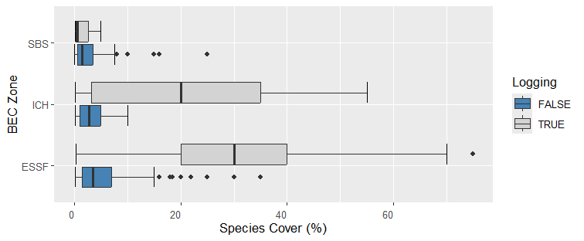

3B. Berry abundance

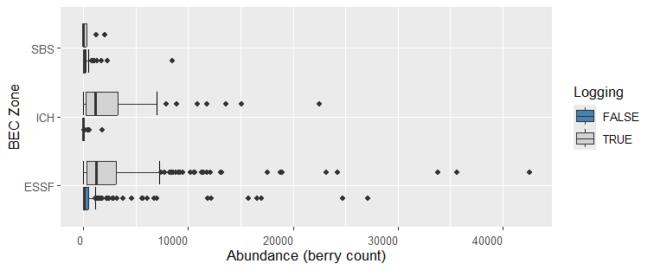

3C. Canopy cover

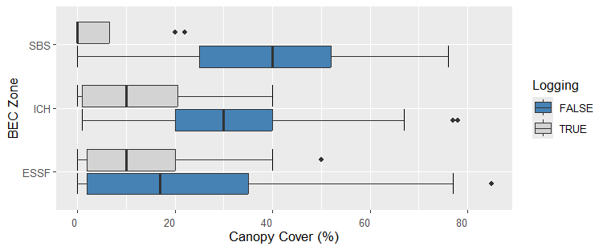

Figure 4.1. Black huckleberry cover (%) by canopy cover in each biogeoclimatic zone (A – ESSF, B – ICH, C – SBS, D – All three zones).

|  |  |
| --- | --- |
| 4.1 A. ESSF | 4.1 B. ICH |
|  |  |
|  |  |
| 4.1 C. SBS | 4.1 D. All three zones |

Figure 4.2. Black huckleberry berry abundance[10] by canopy cover in each biogeoclimatic zone (A – ESSF, B – ICH, C – SBS, D – All three zones).

|  |  |
| --- | --- |
| 4.2 A. ESSF | 4.2 B. ICH |
|  |  |
|  |  |
| 4.2 C. SBS | 4.2 D. All three zones |

Figure 5.1. Black huckleberry species cover (%) by elevation in each biogeoclimatic zone (A – ESSF, B – ICH, C – SBS, D – All three zones).

|  |  |
| --- | --- |
| 5.1 A. ESSF | 5.1 B. ICH |
|  |  |
|  |  |
| 5.1 C. SBS | 5.1 D. All three zones |

Figure 5.2. Black huckleberry berry abundance[11] by elevation in each biogeoclimatic zone (A – ESSF, B – ICH, C – SBS, D – All three zones).

|  |  |
| --- | --- |
| 5.2 A. ESSF | 5.2 B. ICH |
|  |  |
|  |  |
| 5.2 C. SBS | 5.2 D. All three zones |

Table 1. Black huckleberry species cover (%) and berry abundance (#/100m2) statistics by BEC unit.



Table 2. Black huckleberry summary statistics of site variables by BEC unit



Table 3. Black huckleberry cover and canopy cover summary statistics by BEC unit and logging history.



Table 4. Correlations between huckleberry cover, berry abundance, site history (i.e. logged or not logged) and site variables in the ESSF, ICH and SBS biogeoclimatic zones.



Appendix 1. Huckleberry cover (A), berry abundance (B) and tree canopy cover (C) in logged and unlogged sites by BEC unit.

1 A. Huckleberry cover

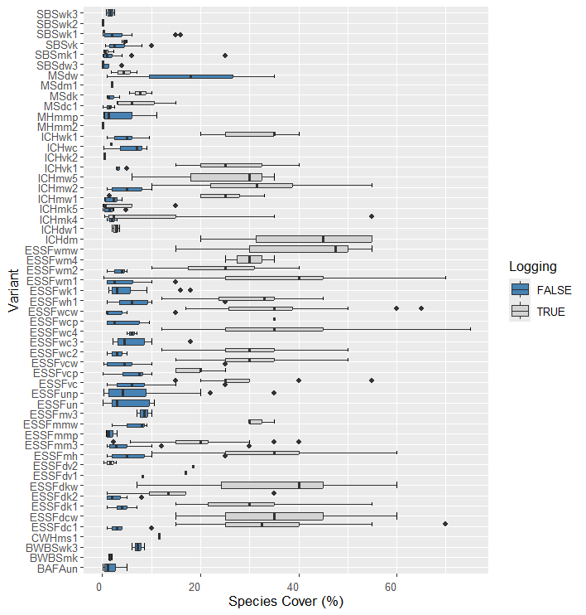

Appendix 1. Huckleberry cover (A), berry abundance (B) and tree canopy cover (C) in logged and unlogged sites by BEC unit

1 B. Berry abundance

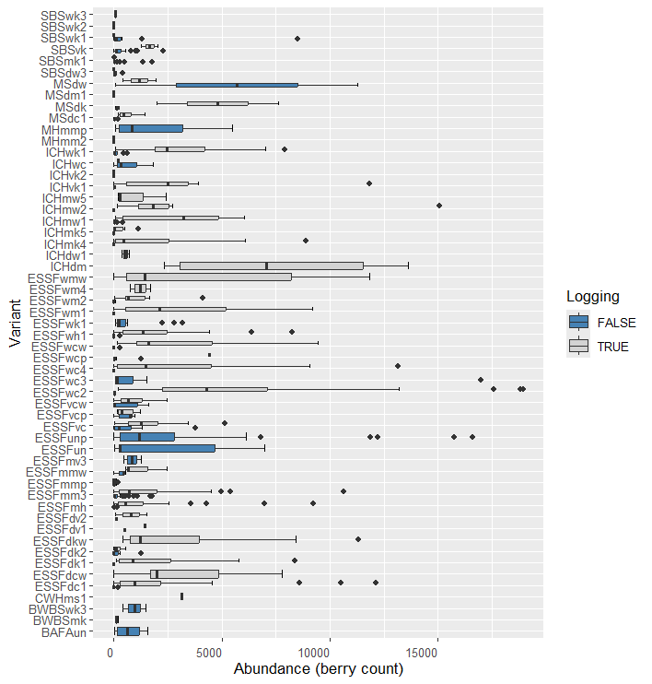

Appendix 1. Huckleberry cover (A), berry abundance (B) and tree canopy cover (C) in logged and unlogged sites by BEC unit

1 C. Canopy cover

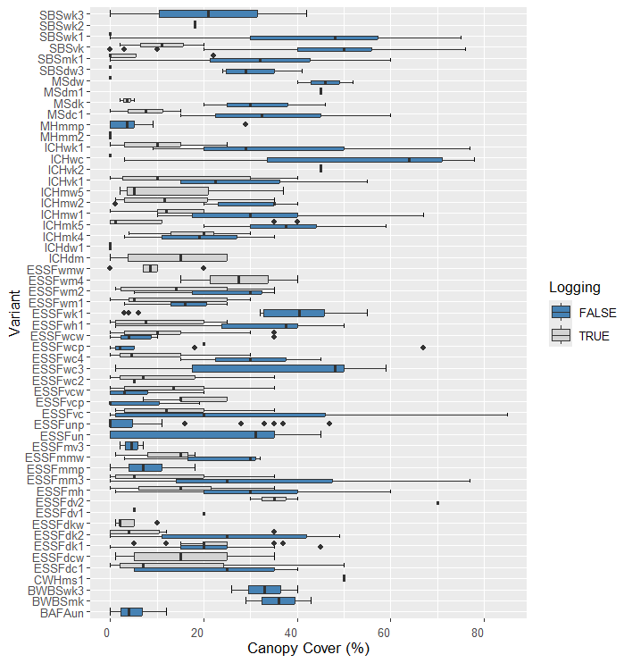

Appendix 2.1 Rpart tree[12] for huckleberry cover (%) by biogeoclimatic zone (A) ESSF, (B) ICH, and (C) SBS.

2.1 A. ESSF huckleberry cover (%)[13].

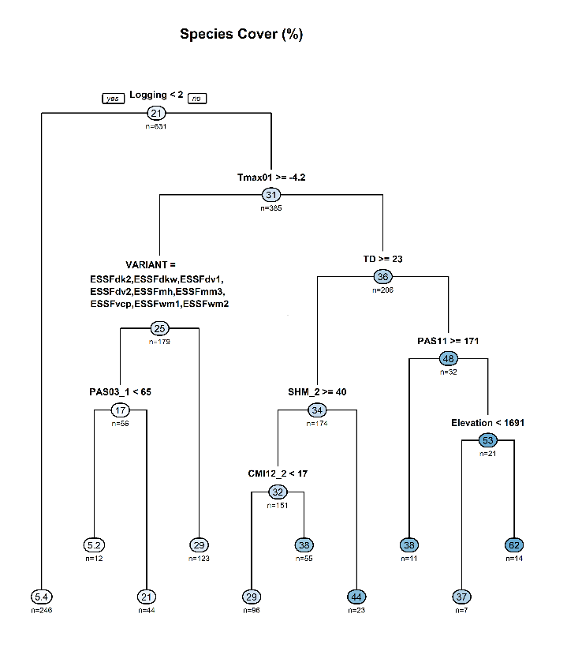

Appendix 2.1. Rpart tree[14] for huckleberry cover (%) by biogeoclimatic zone (A) ESSF, (B) ICH, and (C) SBS.

2.1 B. ICH huckleberry cover (%).

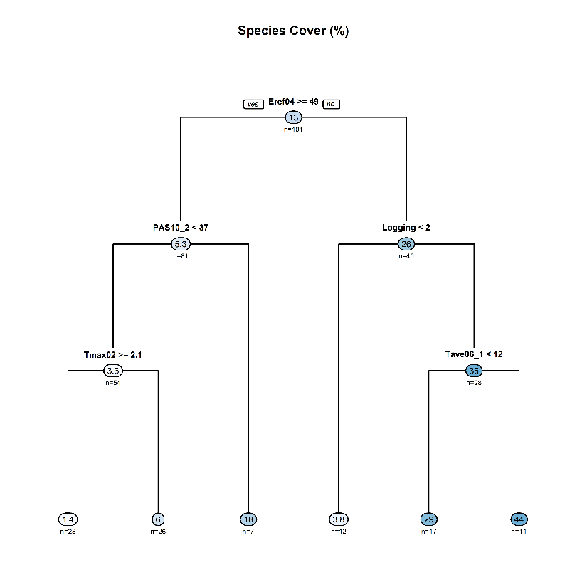

Appendix 2.1. Rpart tree[15] for huckleberry cover (%) by biogeoclimatic zone (A) ESSF, (B) ICH, and (C) SBS.

2.1 C. SBS huckleberry cover (%).

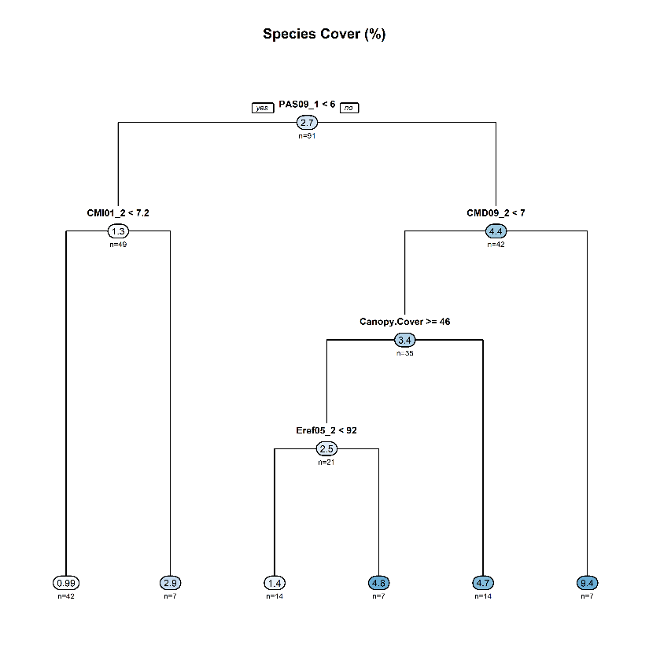

Appendix 2.2. Rpart tree for black huckleberry berry abundance by biogeoclimatic zone (A) ESSF, (B) ICH, and (C) SBS.

2.2 A. ESSF berry abundance.

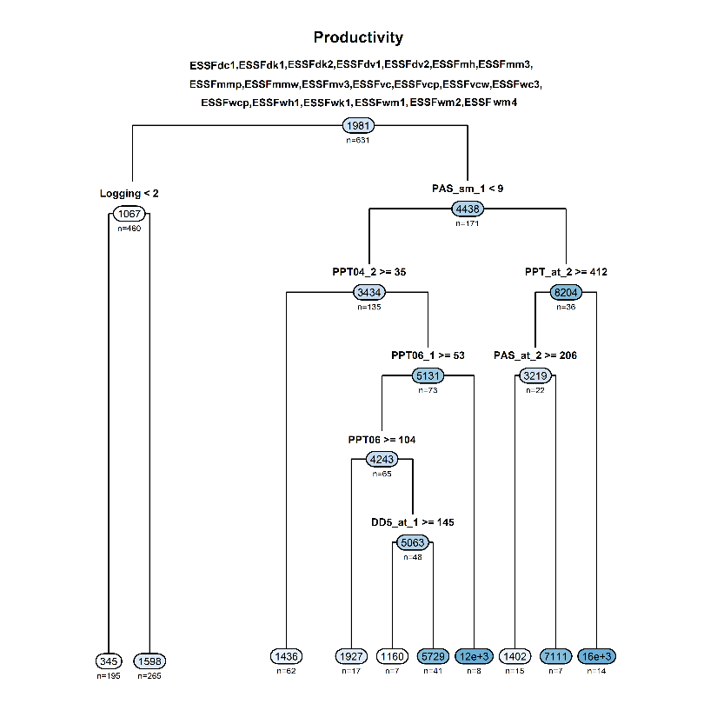

Appendix 2.2 Rpart tree for black huckleberry berry abundance by biogeoclimatic zone (A) ESSF, (B) ICH, and (C) SBS.

2.2 B. ICH berry abundance.

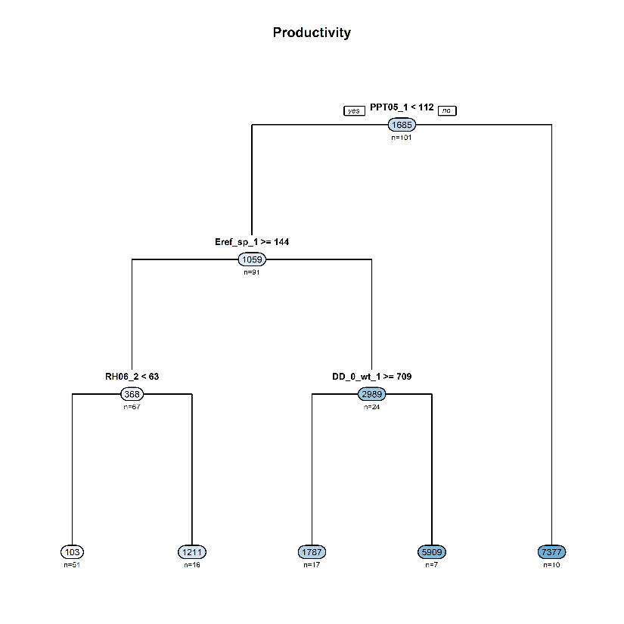

Appendix 2.2. Rpart tree for black huckleberry berry abundance by biogeoclimatic zone (A) ESSF, (B) ICH, and (C) SBS.

2.2 C. SBS berry abundance.

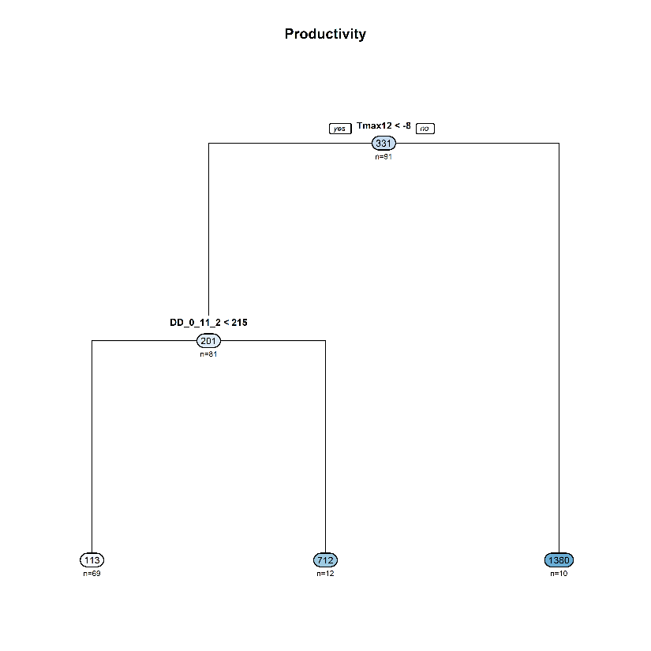

Appendix 3.1.1. Black huckleberry jitter plot of species cover (%) by canopy cover in each biogeoclimatic zone (ESSF, ICH, SBS). These data were collected across different years and were not corrected for year effects.

|  |  |
| --- | --- |
| 3.1.1 A. ESSF | 3.1.1 B. ICH |
|  |  |
|  |  |
| 3.1.1 C. SBS |  |

Appendix 3.1.2. Black huckleberry jitter plot of species cover (%) in sites with and without logging (1=false/2=true)[16] in each biogeoclimatic zone (ESSF, ICH, SBS).

|  |  |
| --- | --- |
| 3.1.2 A. ESSF | 3.1.2 B ICH |
|  |  |
| 3.1.2 C. SBS |  |

Appendix 3.1.3. Black huckleberry jitter plot of species cover (%) by elevation in each biogeoclimatic zone (ESSF, ICH, SBS).

|  |  |
| --- | --- |
| 3.1.3 A. ESSF | 3.1.3 B. ICH |
|  |  |
| 3.1.3 C. SBS |  |

Appendix 3.2.1. Black huckleberry berry jitter plot of abundance by canopy cover in each biogeoclimatic zone (ESSF, ICH, SBS).

|  |  |
| --- | --- |
| 3.2.1 A. ESSF | 3.2.1 B. ICH |
|  |  |
| 3.2.1 C. SBS |  |

Appendix 3.2.2. Black huckleberry jitter plot of berry abundance in sites with and without logging (1=false/2=true)[17] in each biogeoclimatic zone (ESSF, ICH, SBS).

|  |  |
| --- | --- |
| 3.2.2 A. ESSF | 3.2.2 B. ICH |
|  |  |
| 3.2.2 C. SBS |  |

Appendix 3.2.3. Black huckleberry jitter plot of berry abundance by elevation in each biogeoclimatic zone (ESSF, ICH, SBS).

|  |  |
| --- | --- |
| 3.2.3 A. ESSF | 3.2.3 B. ICH |
|  |  |
| 3.2.3 C. SBS |  |

Appendix 4.1. Black huckleberry jitter plot of species cover by canopy cover on logged and unlogged sites in selected biogeoclimatic variants in the ESSF (ESSFdc1, ESSFdk1, ESSFmh, ESSFvc).

|  |  |
| --- | --- |
| 4.1 A. ESSFdc1 | 4.1 B. ESSFdk1 |
|  |  |
| 4.1 C. ESSFmh | 4.1 D. ESSFvc |

Appendix 4.2. Black huckleberry jitter plot of berry abundance by canopy cover on logged and unlogged sites in selected biogeoclimatic variants in the ESSF (ESSFdc1, ESSFdk1, ESSFmh, ESSFvc). Note scale for x and y axes differ in the various subzone variants.

|  |  |
| --- | --- |
| 4.2 A. ESSFdc1 | 4.2 B. ESSFdk1 |
| 4.2 C. ESSFmh | 4.2 D. ESSFvc |

Appendix 4.3. Black huckleberry jitter plot of berry abundance by species cover on logged and unlogged sites in selected biogeoclimatic variants in the ESSF (ESSFdc1, ESSFdk1, ESSFmh, ESSFvc).

|  |  |
| --- | --- |
| 4.3 A. ESSFdc1 | 4.3 B. ESSFdk1 |
| 4.3 C. ESSFmh | 4.3 D. ESSFvc |

1. Site data included BEC unit, canopy cover, % slope, aspect (azimuth), elevation, and whether the site had been logged or not. Azimuth values were converted to “folded aspect” such that the sites that receive comparable solar radiation hence heatload have comparable aspect values (See [McCune, 2007](https://sites.science.oregonstate.edu/~mccuneb/JVSreprint13.603-606.pdf)).
2. *Vaccinium membranaceum* North American distribution map from [Virginia Tech Dendrology Fact Sheet](https://dendro.cnre.vt.edu/dendrology/images/Vaccinium%20membranaceum/map.jpg)
3. Site data included BEC unit, canopy cover, % slope, aspect (azimuth), elevation, latitude and longitude.
4. Aspect azimuth values were converted to “folded aspect” so that the site that receive comparable solar radiation – i.e. SSE- and SSW-facing have the same value (See McCune 2007).
5. Group 1 BEC units included the ESSFmmw, vc, vcw, wc2, wc4, wcp, wcw and wh1 BEC units(See [BECweb](https://www.for.gov.bc.ca/hre/becweb/resources/classificationreports/index.html) for description of BEC units including subzones and subzone variants.
6. Group 2 BEC units included the ESSFdk2, dkw, dv1, dv2, mh, mm3, vcp, wm1 and wm2 BEC units.
7. Group 3 included the ESSFdcw, dkw, un, unp, wc2, wc4, wcw and wmw BEC units.
8. Group 4 included the ESSFdc1, ESSFdk1, ESSFdk2, ESSFdv1, ESSFdv2, ESSFmh, ESSFmm3, ESSFmmp, ESSFmmw, ESSFmv3, ESSFvc, ESSFvcp, ESSFvcw, ESSFwc3, ESSFwcp, ESSFwh1, ESSFwk1, ESSFwm1, ESSFwm2 and ESSFwm4 BEC units.
9. Berry abundance outliers (greatest 5%) removed.
10. Berry abundance outliers (greatest 5%) removed.
11. Berry abundance outliers (greatest 5%) removed.
12. The rpart analysis identifies the predictor variables that best explain the response (i.e. huckleberry cover or abundance. The analysis is done in in a recursive manner. The first split in the “tree” corresponds to the predictor variable that is best correlated with the response - in these 3 analyses the response is huckleberry plant cover. In ESSF sites the most important first predictor factor was logging - with sites on the right side are the logged sites (the mean cover value for this group of sites is 31%, n=385). On the left side there is the group of unlogged sites, and the mean cover is 5.4%, n=246. The subsequent split then identifies the factor in logged sites that is best correlated with plant cover. In this case it is Tmax01 (maximum temperature in December) with greater cover where it was <-4.20C (i.e. mean cover =36%, n=206) vs where Tmax01 was >=-4.20C (mean cover= 25%, n=179). In the sites where Tmax01 >=-4.20C (i.e. the left side of this split cover is less in the listed subzones and subzone variants (mean cover =17%, n=56) vs in the sites in the right side of the split which are in the ESSFmmw, vc, vcw, wc2, wc4, wcp, wcw and wh1 subzones and subzone variants (mean cover=29%, n=123).
13. Summary - Cover is less in logged (far left branch) vs unlogged sites (right side). In unlogged sites, cover is less where Tmax01>=-4.2oC. Where Tmax01>=-4.2oC cover is less in sites in the BEC units listed in the graphic compared with those in the ESSFmmw, vc, vcw, wc2, wc4, wcp, wcw and wh1.
14. The rpart analysis identifies the predictor variables that best explain the response (i.e. huckleberry cover or abundance. The analysis is done in in a recursive manner. The first split in the “tree” corresponds to the predictor variable that is best correlated with the response variable.
15. The rpart analysis identifies the predictor variables that best explain the response (i.e. huckleberry cover or abundance. The analysis is done in in a recursive manner. The first split in the “tree” corresponds to the predictor variable that is best correlated with the response variable.
16. In each xy plots (i.e. A, B and C) the sites (circles) on the left side of the xy plot (centered around 1) were not logged and the sites (circles) on the right side of the xy plot (centered around 2) were logged.
17. In each xy plots (i.e. A, B and C) the sites (circles) on the left side of the xy plot (centered around 1) were not logged and the sites (circles) on the right side of the xy plot (centered around 2) were logged.